Website Planning Document

The Mountain Spoke

Author: Leah DeSpain Tomlinson

Site Purpose

Provide a user friendly and refreshing experience reflecting the culture of biking enthusiasm to those who visit the page by offering products, repairs, parts, and tours. The main focus of the site is to cater to the bicycling enthusiast of the area making it a better experience for current clients and a draw to potential clients. A secondary motive of doing this is to draw in bicycle enthusiast from around the world to experience the tours created by the company.

Target Audience

Our main target audience will be those bicycling enthusiast. We have determined the majority of our members will be persons likely 35-50 years old with mid to high income. These people will be male and female but mostly male adventurists or bicycle enthusiast.

Site Map

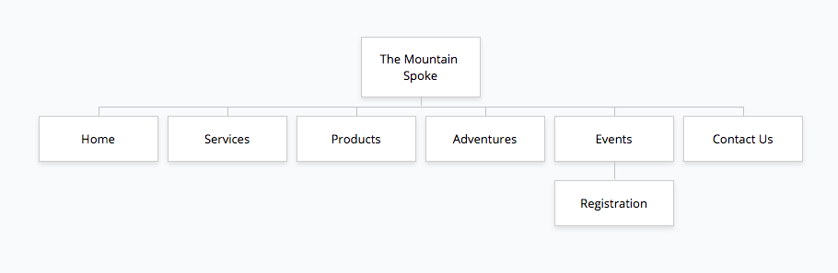

Color Scheme

The colors that we will be using on the site will be yellow, gray, and black because they represent youthfulness and optimism. We also chose gray to represent calmness and simplicity as well as black for luxury. We believe this will appeal to the clients of The Mountain Spoke and really project the companies overall feel to all visitors.



Typography

As for typography we will be using Unica One for all aspects except for paragraphs, which will be in Vollkorn. We feel this will give the right style to our site.

